**Evidence for Implementation and Testing Unit.**

Name: Heather Rae

Cohort: 15

Date here: 2017

**I.T 1- Demonstrate one example of encapsulation that you have written in a program.**

**I.T 2 - Example the use of inheritance in a program.**

**I.T 3 - Example of searching data.**

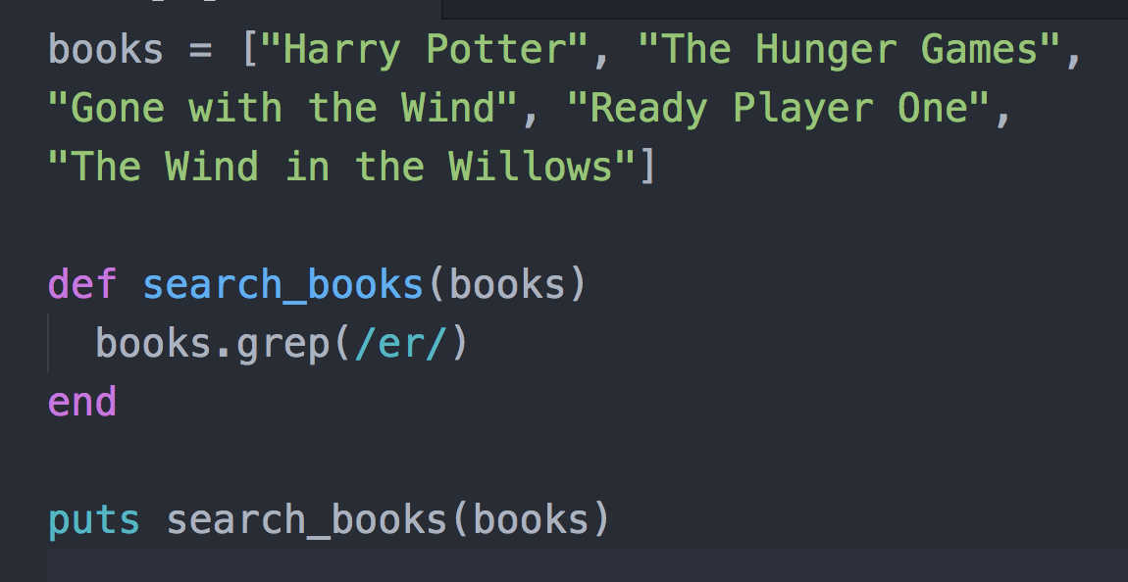

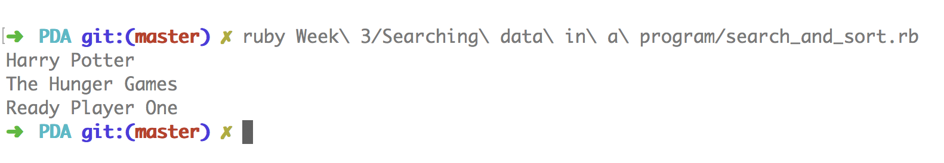

**I.T 4 - Demonstrate sorting data.**

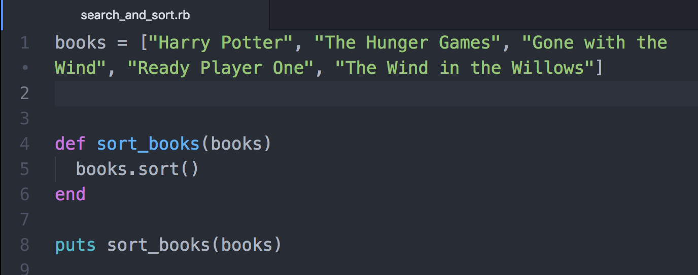

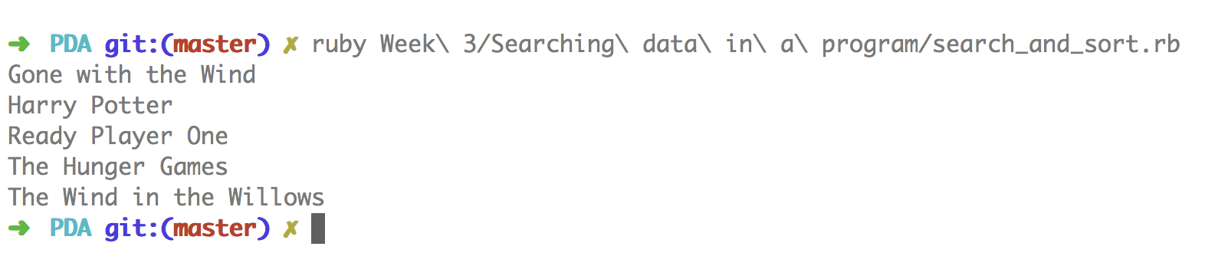

**I.T 5 - Example of an array, a function that uses an array and the result**

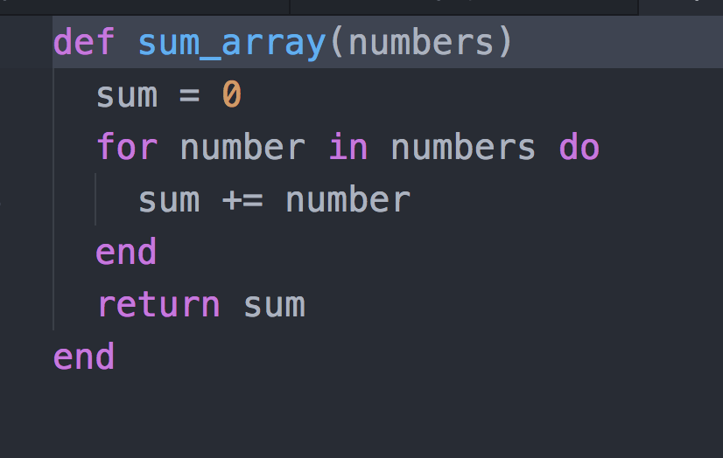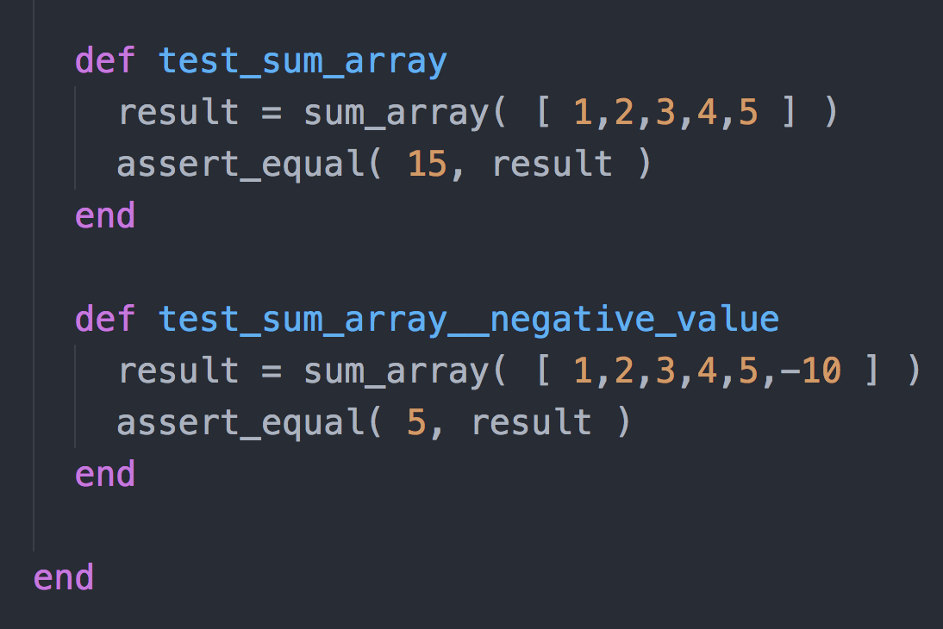

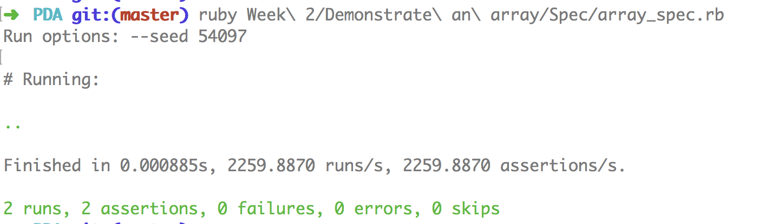

**I.T 6 - Example of a hash, a function that uses a hash and the result**

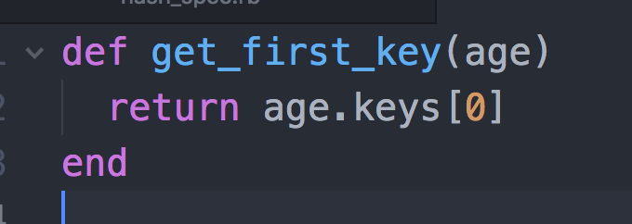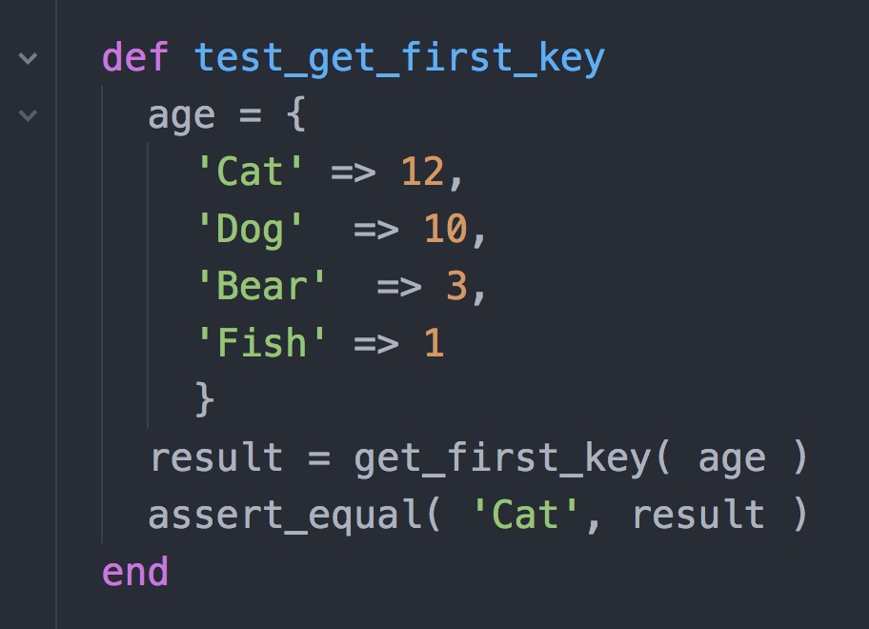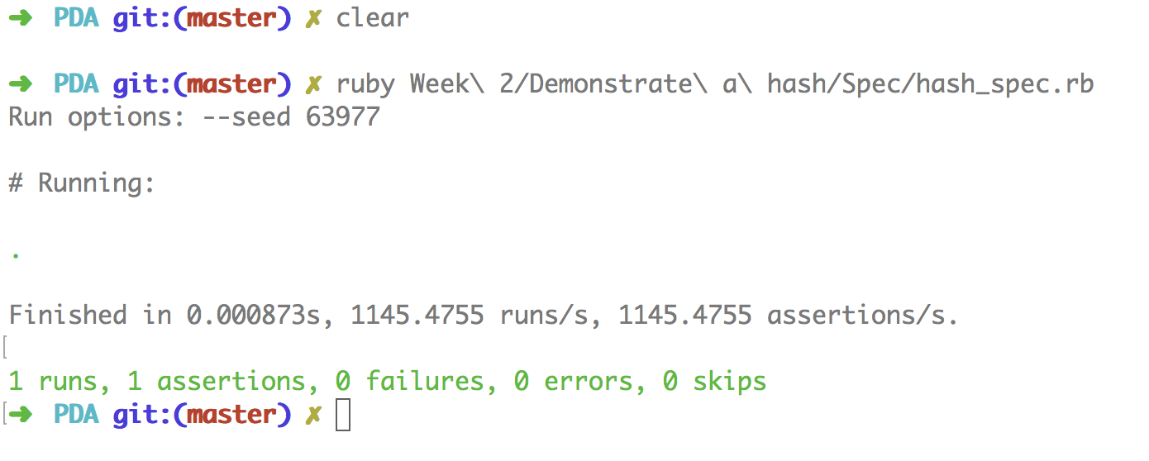

**I.T 7 - Example of polymorphism in a program**

